

Education Accelerator

Walkthrough Guide

Table of Contents

Overview 3

Sample applications 3

Walkthrough the Higher Education Portal 4

Step 1: Sign in experience 4

Step 2: Landing page 5

Step 3: Advisor connection via Tele-advising 6

Step 4: View Personalized Progress 6

Step 5: Events within reach 7

Walkthrough the higher education app 8

Step 1: Student form 8

Step 2: Student internship application status form 8

Step 3: Advisor dashboard 9

Step 4: Business partner dashboard 10

Walkthrough the program registration portal 10

Step 1: Browse program catalog 10

Step 2: View course details 11

Step 3: View current registrations 12

Walkthrough program management app 13

Step 1: Create, edit, and maintain a library of available programs 13

Walkthrough the K-12 portal 14

Step 1: Sign in experience 14

Step 2: Landing page 15

Step 3: View assignments 15

Step 4: Check attendance 15

Step 5: Get involved via extracurricular activities 16

Step 6: Check the School Calendar 16

Step 7: View course history 17

Walkthrough the K-12 app 17

Step 1: View student and school data 17

Step 2: View teacher certification and credential data 18

# Overview

Microsoft Dataverse helps customers eliminate data silos, enable power insights, and act on their own data. This need is nowhere more relevant than in education where data often deals with students and their ability to navigate a complex system to reach their goals.

Microsoft is working closely with education ISV and SI partners around the world to make Microsoft Dataverse more relevant to them by shaping the roadmap for the education accelerator with them. Microsoft is dedicated to enabling partners to build and focus their efforts on vertical industries in a streamlined approach. The education accelerator provides a uniform platform for those who wish to connect, embed, or extend Microsoft Power Platform and Microsoft Dynamics 365.

The education accelerator encompasses two components: an education data model and sample applications. The education data model includes concepts for both higher education (i.e. tertiary education) and K-12 education (i.e. primary and secondary education) in a single data model. The sample applications are designed to show use cases of the data model and help partners deliver solutions to their customers faster. Some of the sample applications are contextualized specifically for higher education scenarios and some of the sample applications and sample data are contextualized specifically for K-12 education. This documentation provides a walkthrough of the key components of all sample applications.

The education data model, sample applications, installation guide, and other technical documentation can be downloaded for free from [GitHub.](https://github.com/microsoft/Industry-Accelerator-Education/releases)

# Sample applications

The education accelerator includes the following sample applications that are contextualized for higher education:

* Higher education portal
* Higher education app
* Program registration portal
* Program management app

The education accelerator includes the following sample applications that are contextualized for K-12 education:

* K-12 portal
* K-12 app

# 

# Walkthrough the Higher Education Portal

## Step 1: Sign in experience

Anton Chew is a student at Contoso University. Anton logs into the **higher education portal** and is instantly impressed by an updated design and user experience.

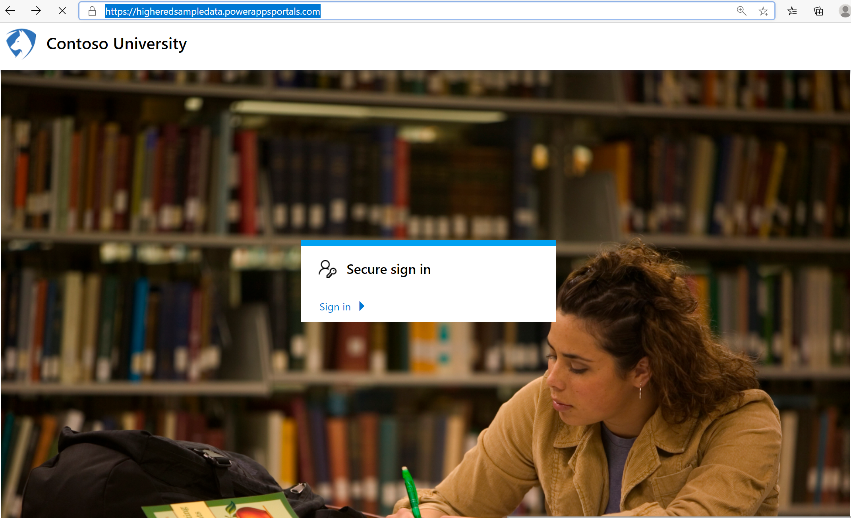

Anton **signs in** with his credentials.

## Step 2: Landing page

The **landing page** for the higher education portal allows Anton to access multiple sources of data through a single location, including relevant university information, his personal course history and achievements, and the status of grant and scholarship applications.

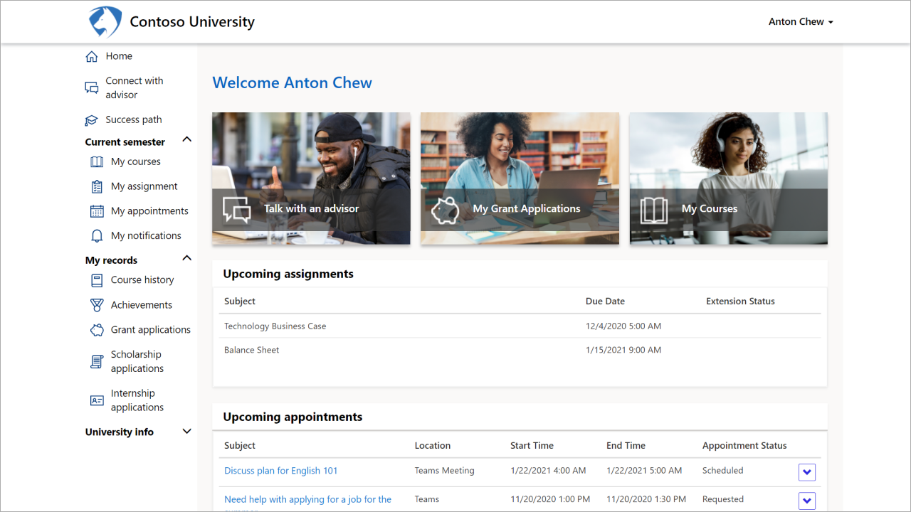

## Step 3: Advisor connection via Tele-advising

Anton uses the **connect with advisor** link, on the left-hand navigation bar, to schedule a meeting with his advisor.

Anton creates an appointment request with a date and time to work with his busy schedule. In the **description** box, he adds a brief explanation for the meeting request. This description helps his advisor prepare for the meeting.

## Step 4: View Personalized Progress

Anton is curious about his progress toward his bachelor’s in accounting. On the **success path** screen, Anton views the courses needed toward his degree, both completed and not completed, and views he currently achieved 25% of the program requirements. This percentage increases as he completes additional required courses.

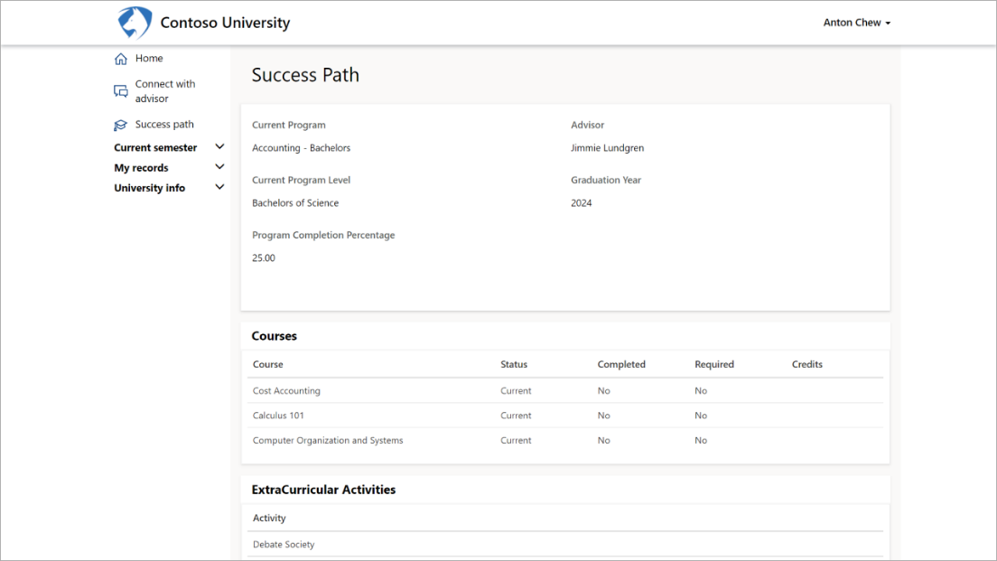

## Step 5: Events within reach

Anton can search, view, and register for digital and in-person **events**. This extension of the higher education portal is built on Dynamics 365 so partners and customers can use advanced marketing capabilities. A Dynamics 365 Marketing license is required for this feature.

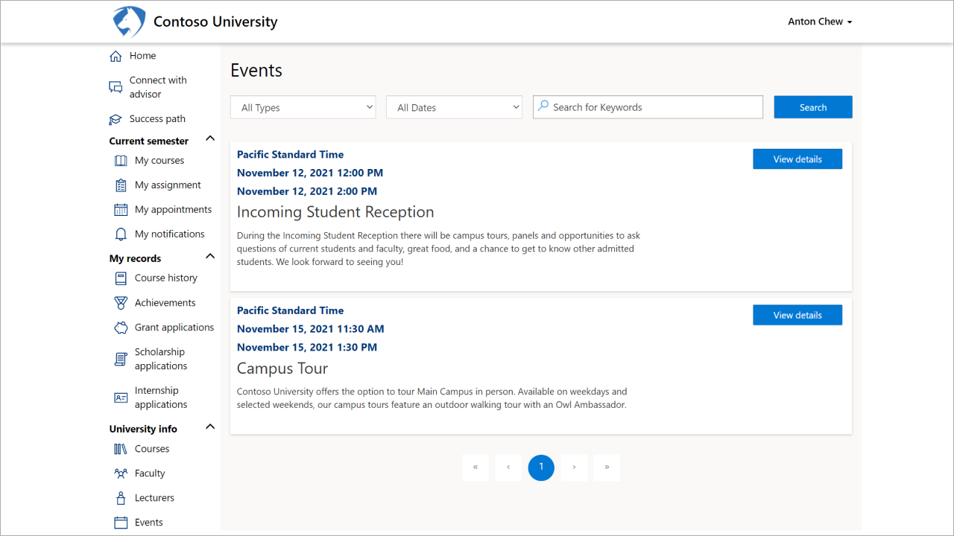

# Walkthrough the higher education app

## Step 1: Student contact

To assist Anton and other students, the University Administrator uses the **contact** form in the **higher education app**. The form shows student information such as contact information, course load, areas of study, degree, course history, and test scores, in the context of the app and the interface. The student record becomes the source of truth to deliver the right ongoing engagements for providing the best support throughout the student lifecycle.

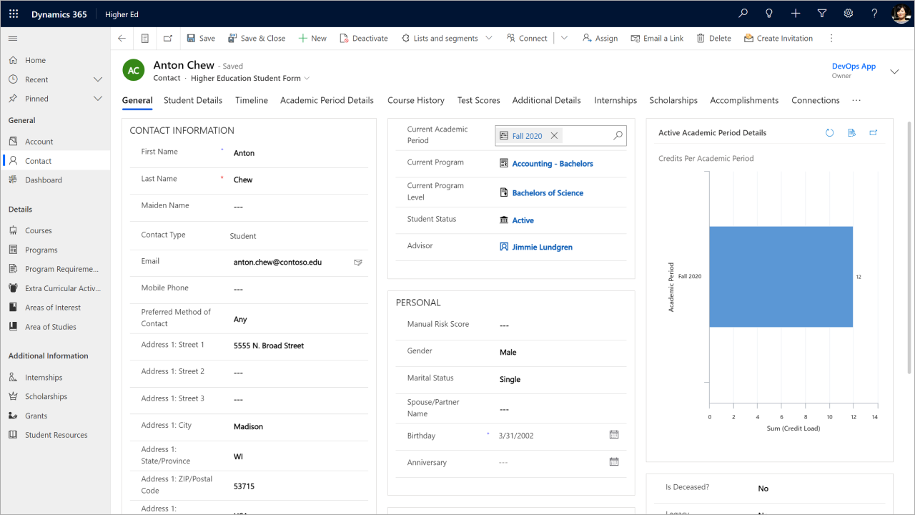

## Step 2: Student internship application status form

The University Administrator uses the **internship** form to track the internship application status for Anton and other students.

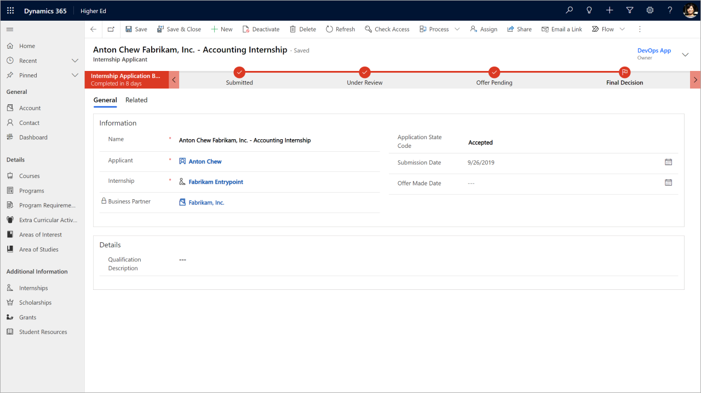

## Step 3: Advisor dashboard

The University Advisor logs into the **advisor dashboard** to view top and bottom performing students and upcoming appointments with students.

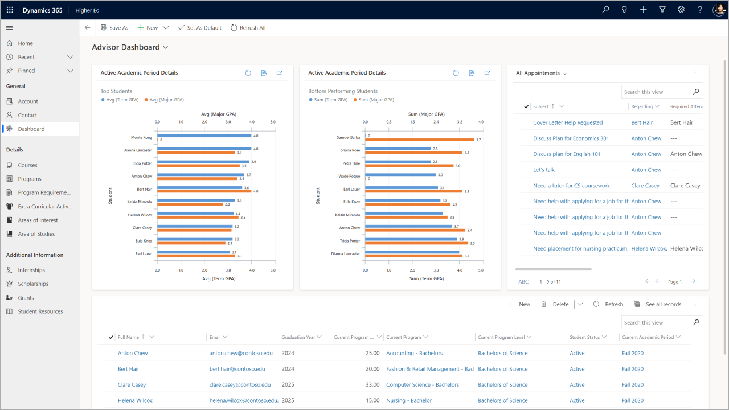

## Step 4: Business partner dashboard

A business partner is any organization that's willing to engage with the university for events, hackathons, internships, scholarships, or grants. The University Administrator works with business partners to bring more internships, scholarships and grants to their students. The Business Partner effortlessly uses the **business partner dashboard** in the higher education app to review existing applicants and their application status.

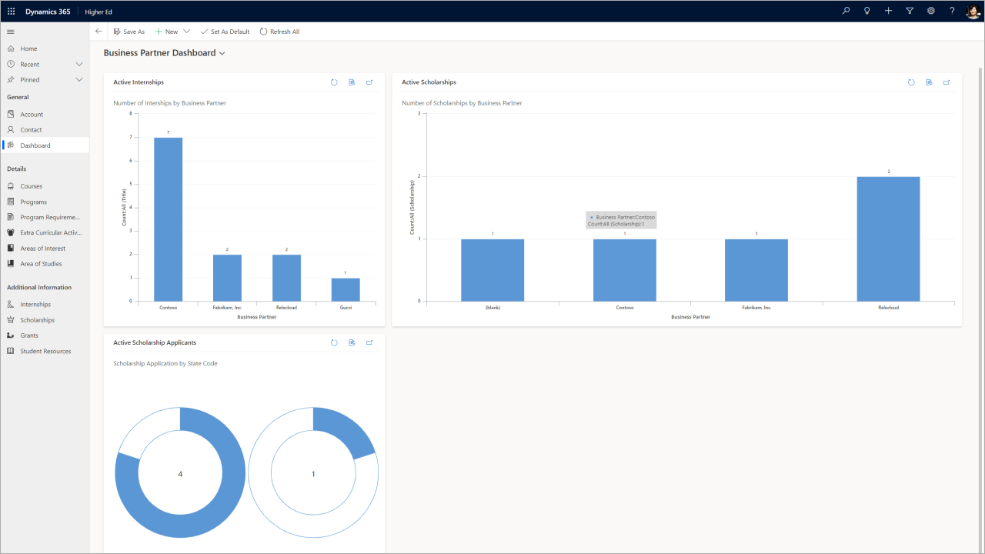

## 

# Walkthrough the program registration portal

The **program registration portal** is contextualized for higher education but note that it can be adapted for K-12 scenarios. It can also be adopted as a “standalone” portal or integrated with the higher education portal. When installed as a standalone portal, the program registration portal uses top navigation rather than left side navigation. The screenshots below show the standalone portal experience.

## Step 1: Browse program catalog

Anton Chew is a student at Contoso University. He uses the **program catalog** in the program registration portal to discover academic and non-academic programs offered by his university, such as tutoring services, sports teams, and community service opportunities.

## Step 2: View course details

Anton is interested in a personal finance course, so he views the **course details**. The course is full, so he **registers for the waitlist**.

## Step 3: View current registrations

Anton views current registrations for multiple programs on the **My current registrations** page.

# Walkthrough program management app

## Step 1: Create, edit, and maintain a library of available programs

The University Administrator uses the **program management app** to create, edit, and maintain a library of available **programs** that are open for registration. The University Administrator also uses this app to manage the programs, courses, course sections and enrollments and to configure the school calendar, bell schedules, and academic periods.

# Walkthrough the K-12 portal

## Step 1: Sign in experience

Stuart Ulmer, a student at Contoso High School, missed his Math class today. Knowing his teacher adds new assignments online daily, he logs into the **K-12 portal** to learn what he missed.

## Step 2: Landing page

Stuart can see his current homework and assignments directly from the **landing page**. He chooses the **assignments** tab to look more closely at his assignments.

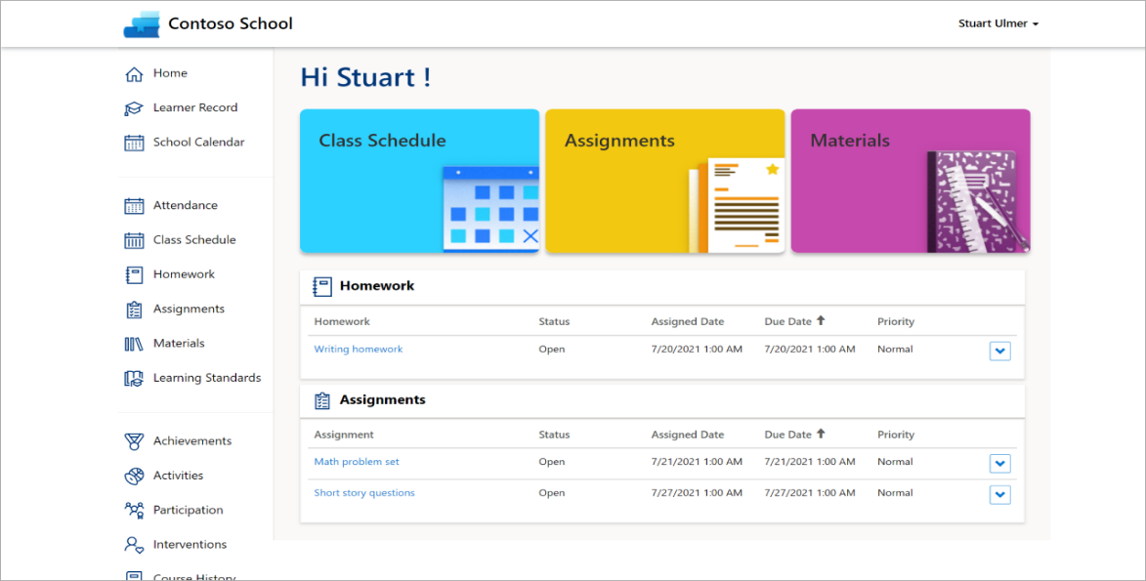

## Step 3: View assignments

Stuart wants to focus only on his Math homework, so he selects **Math problem set** to see details about that assignment.

## Step 4: Check attendance

Stuart is curious if he was marked absent from the classes he missed, so he checks his **attendance.**

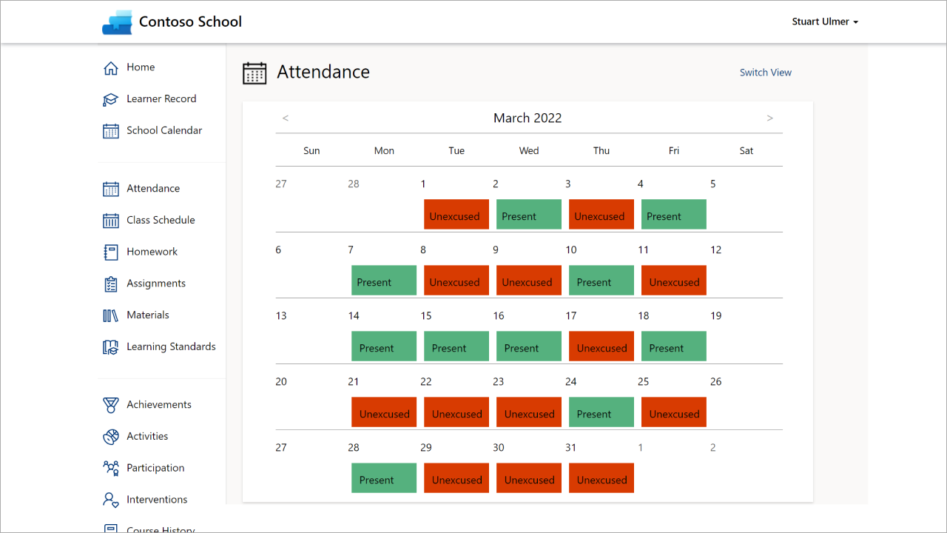

## Step 5: Get involved via extracurricular activities

Stuart heard from a friend about an after-school club for Archery. He wants to learn more, so he looks at the **activities** to see this club as well as explore all the other activities offered at his school. Here he learns how to get involved.

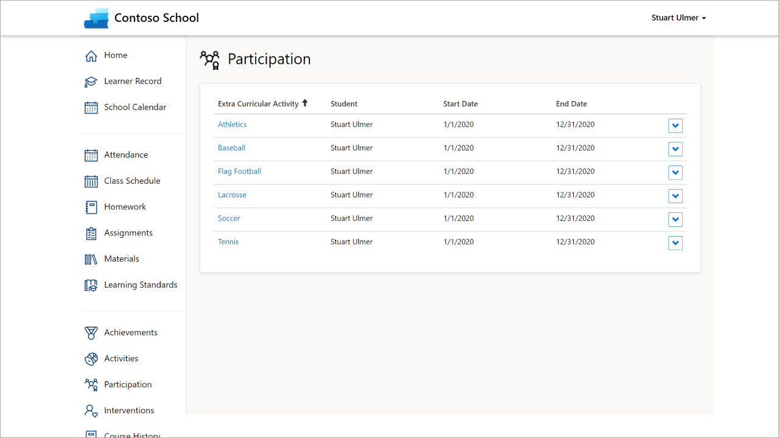

## Step 6: Check the School Calendar

Stuart’s family wants to plan a vacation. His mom, Patricia knows there are some school holidays in March, but she is not sure of the dates. Just as Stuart, she logs into the K-12 portal. She navigates to the **school calendar** and checks which days are holidays in March.

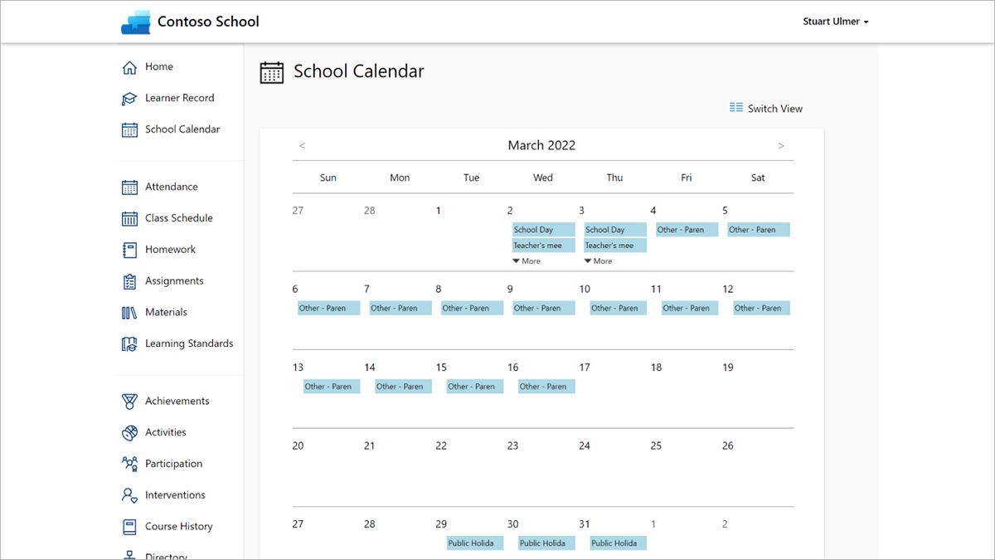

## Step 7: View course history

Patricia can also easily view Stuart’s **course history**, including both current and previous courses.

# Walkthrough the K-12 app

## Step 1: View student and school data

The School Administrator has a complete view of **attendance, courses, internships, accomplishments, extracurricular activities, interventions, assessments**, and **behavior incidents**. The School Administrator uses this single view to access information for their students and take informed actions to support students.

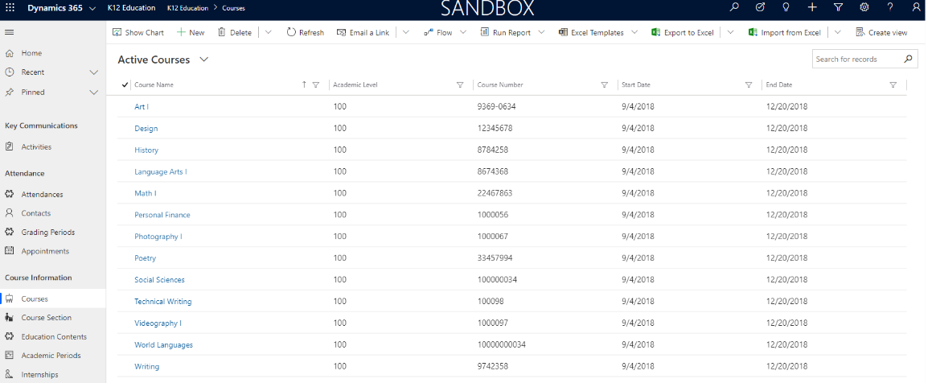

## Step 2: View teacher certification and credential data

The School Administrator can also view teachers' **certification** and **credential** status and track their progress towards completing new certifications.

